Project Design Phase-II

Data Flow Diagram & User Stories

|  |  |
| --- | --- |
| **Date** | 23 October 2022 |
| **Team ID** | PNT2022TMID37334 |
| **Project Name** | Web phishing detection |
| **Maximum Marks** | 4 Marks |

# Data Flow Diagrams:

A data flow diagram (DFD) is **a graphical or visual representation using a standardized set of symbols and notations to describe a business's operations through data movement .** It uses defined symbols like rectangles, circles and arrows, plus short text labels, to show data inputs, outputs, storage points and the routes between each destination.

# Web Phishing Detection:

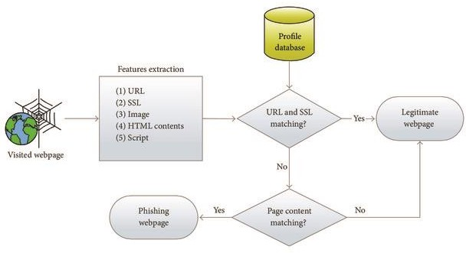

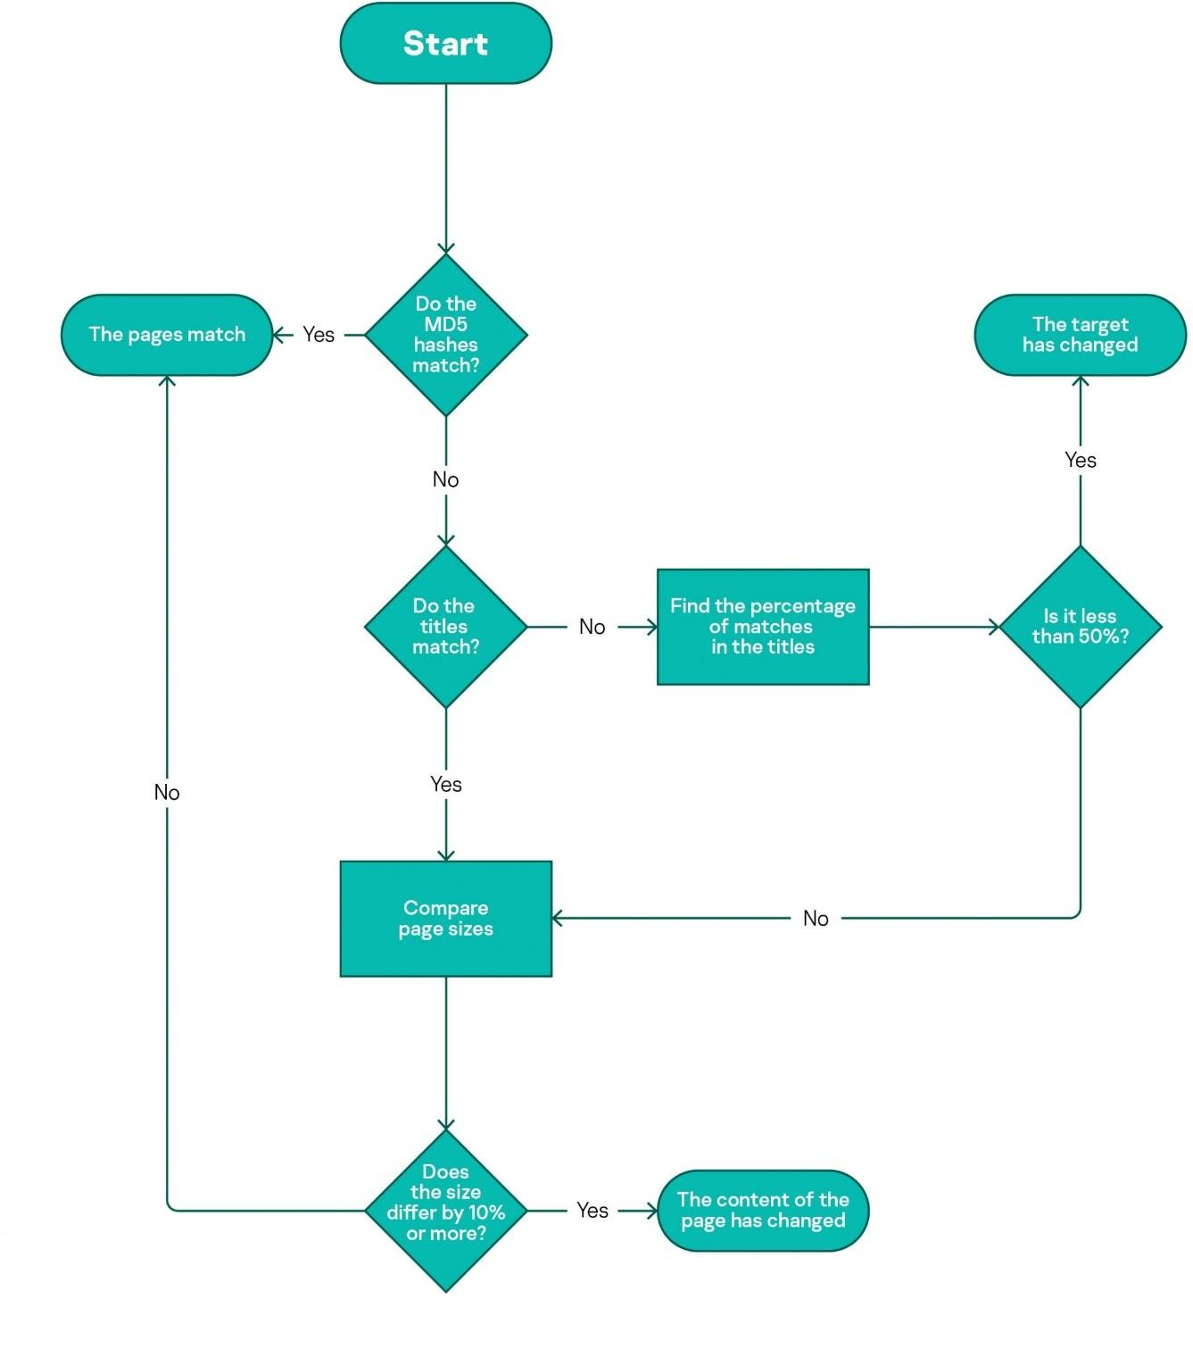

**User Stories:**

Use the below template to list all the user stories for the product.

|  |  |  |  |  |  |
| --- | --- | --- | --- | --- | --- |
| **User Type** | **Functional**  **Requirement (Epic)** | **User Story Number** | **User Story / Task** | **Acceptance criteria** | **Priority** |
| Customer (Mobile user) | Download the intelligent system | USN-1 | As a user, I can download the intelligent system and detect phishing websites.  The system starts working immediately once you start the computer. | I can download it easily from internet. | High |
|  | register | USN-2 | As a user, I will register for the system using my mail and receive confirmation email once I have  registered for the application | I can receive confirmation email &  click confirm | Medium |
|  | login | USN-3 | As a user, I can login to the application and enter my details and use the application. | I can Login and give my details | Medium |
|  | Provide access | USN-4 | The user should provide access to google and the user’s search engine so that the intelligent system can detect phishing websites. | I have to provide access to search engines | High |
|  | use | USN-5 | The user can use the intelligent system to detect phishing website | Finally I can use the intelli  -gent system | Medium |
| Customer (Web user) | The functional requirements are same as mobile  user. | Same as mobile user | Same as mobile user | Same as mobile user | High when compared to mobile  users |